3.84: 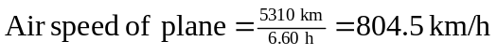
With wind from A to B:
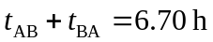 (1)
Same distance both ways:
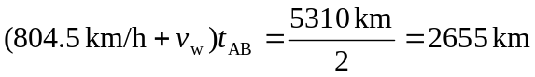 (2)
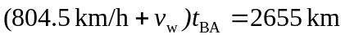 (3)
Solve (1), (2), and (3) to obtain wind speed 